Reference : <https://www.youtube.com/watch?v=nWM_7iql9bA>

<https://www.codeguru.com/azure_activities/an-introduction-to-azure-data-factory-and-etl.html?utm_source=Direct>

The Azure Data Factory (ADF) is a service designed to allow developers to integrate different data sources. It's actually a platform of Microsoft Azure to solve problems related to data sources, integration, and to store relational and non-relational data. The role of Azure Data Factory is to create data factories on the Cloud. In other words, ADF is a managed Cloud service that is built for complex hybrid extract-transform-load (ETL), extract-load-transform (ELT), and data integration projects. ADF also provides an up-to-the moment monitoring dashboard, which means you can deploy your data pipelines and immediately begin to view them as part of your monitoring dashboard. Azure Data factory supports computing services such as HD Insight, Hadoop, Spark, Azure Data Lake, and Analytics to do all these tasks.

Data factory orchestrates the whole process of integrating various sources and brings in the data to azure cloud storage and helps in processing and transforming the data and analyze and move the data to Azure sql database etc.

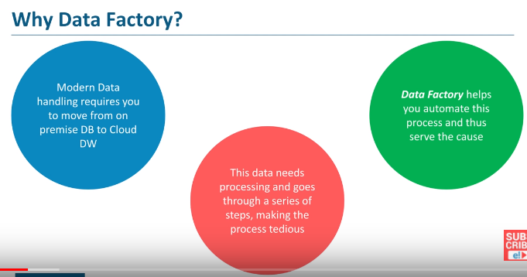

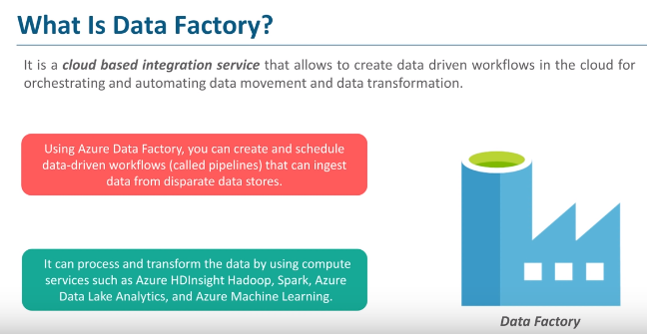

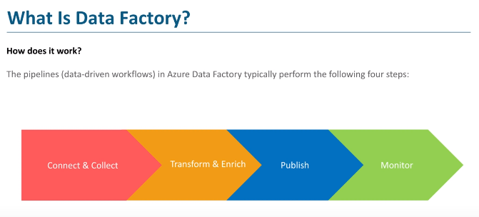

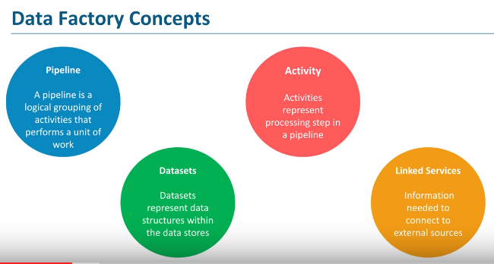

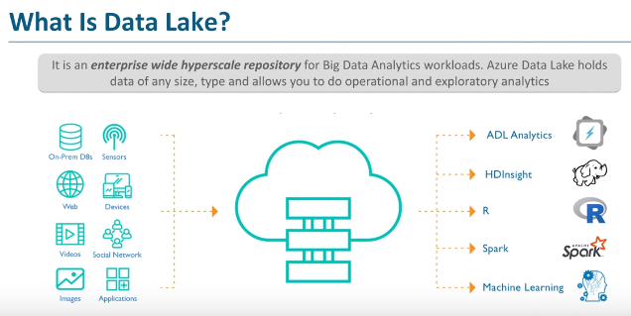

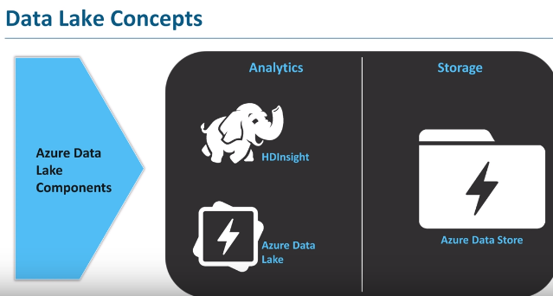

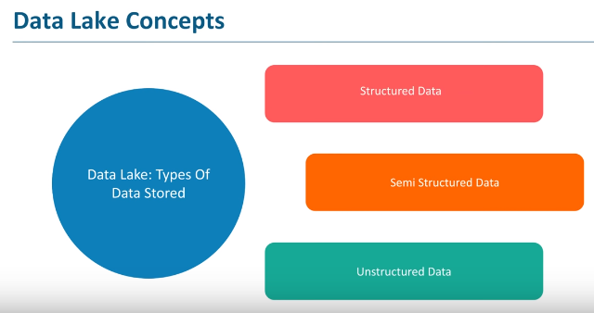

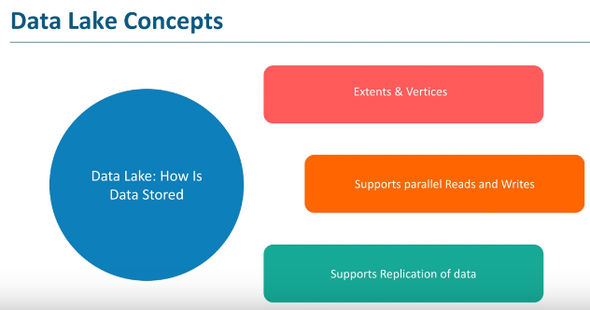

Extents is nothing but the chunks(main data is split into chunks for parallel processing)

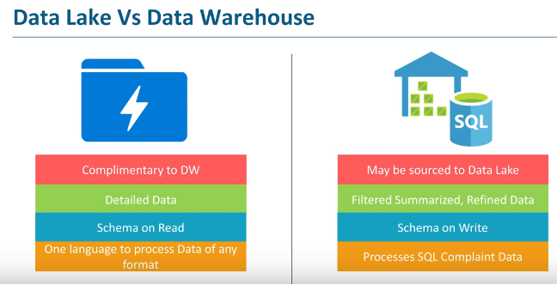

**Advantages of Azure Data Factory**

ADF service lets companies transform all their raw big data from relational, non-relational, and other storage systems. ADF service uses a drag-and-drop interface for ease of use. By using visual tools, you can iteratively build, debug, deploy, operationalize, and monitor your big data pipelines. By using Azure Data Factory, companies can create and schedule data-driven workflows, which are called *pipelines*, that can ingest data from disparate data stores.

Users also can publish and output data-to-data stores, such as Azure SQL Data Warehouse for use by business intelligence (BI) applications. By using Azure Data Factory, users can organize raw data into meaningful data stores and data lakes for better business decisions.